**Mental Health Integrated Community Care Transformation**

1. **Introduction**

This paper is to update the Health Scrutiny Committee on the Community Mental Health Transformation programme across Lancashire and South Cumbria.

**2.0 National Context and Background**

*This programme is overseeing the single biggest investment in mental health services that we have seen in recent times; Lancashire and South Cumbria will receive £11.6m in NHS transformation funding. The aim is to develop a new model of care that is set out in the NHSE Community Mental Health Framework.*

The NHSE Community Mental Health Framework sets out a model of care that enhances community based support for people living with moderate to severe mental illness and complex needs. The funding provides local NHS organisations the opportunity to focus on population health and reduce inequalities. Lancashire and South Cumbria NHS Foundation Trust (LSCFT) aims to deliver on this transformation programme through the strengthening of local partnerships with local authority-funded services and the Voluntary, Community, Social, Faith and Enterprise (VCFSE) sector.

Nationally there have been early implementer sites of the model and a new 4 week waiting time target is being piloted with the ambition that people moderately to severely affected by mental illness can expect to receive the right treatment at the right time within 4 weeks from 2023/24. The following principles are fundamental to the new community models:

* Removing the idea of thresholds and multiple assessments – if someone is unwell and in need of support, they should receive it, as they would in acute care. If that service turns out to not be quite right then the system should be flexible enough to offer other options and step up and step down care as
* A ‘no wrong door’ policy, or even a ‘no door’ policy
* People should be able to tell their story and experience just once
* A focus on specific, tailored and inclusive support needed for underrepresented groups – including the black, Asian and minority ethnic (BAME) population and people from lesbian, gay, bisexual, transgender, questioning and intersex (LGBTQI) communities.
* Personalised health and social care support – including entitlements under the Care Act and personal health budgets.
* Joint commissioning of services for people and communities

**3.0 Community Mental Health Model**

The ambition is to improve the quality of person centred care by enhancing the multi-agency team working approach: with a shared practice model that is strengths based, trauma informed and solutions focused. The community model is designed to meet the changing needs of adults and older adults with serious mental illness, and those with very complex needs but who may not currently meet the thresholds for secondary care services. This programme provides a unique opportunity to invest in primary care, social care and VCSFE provision as areas where there has been historic under-development. The framework for the model is outlined below.

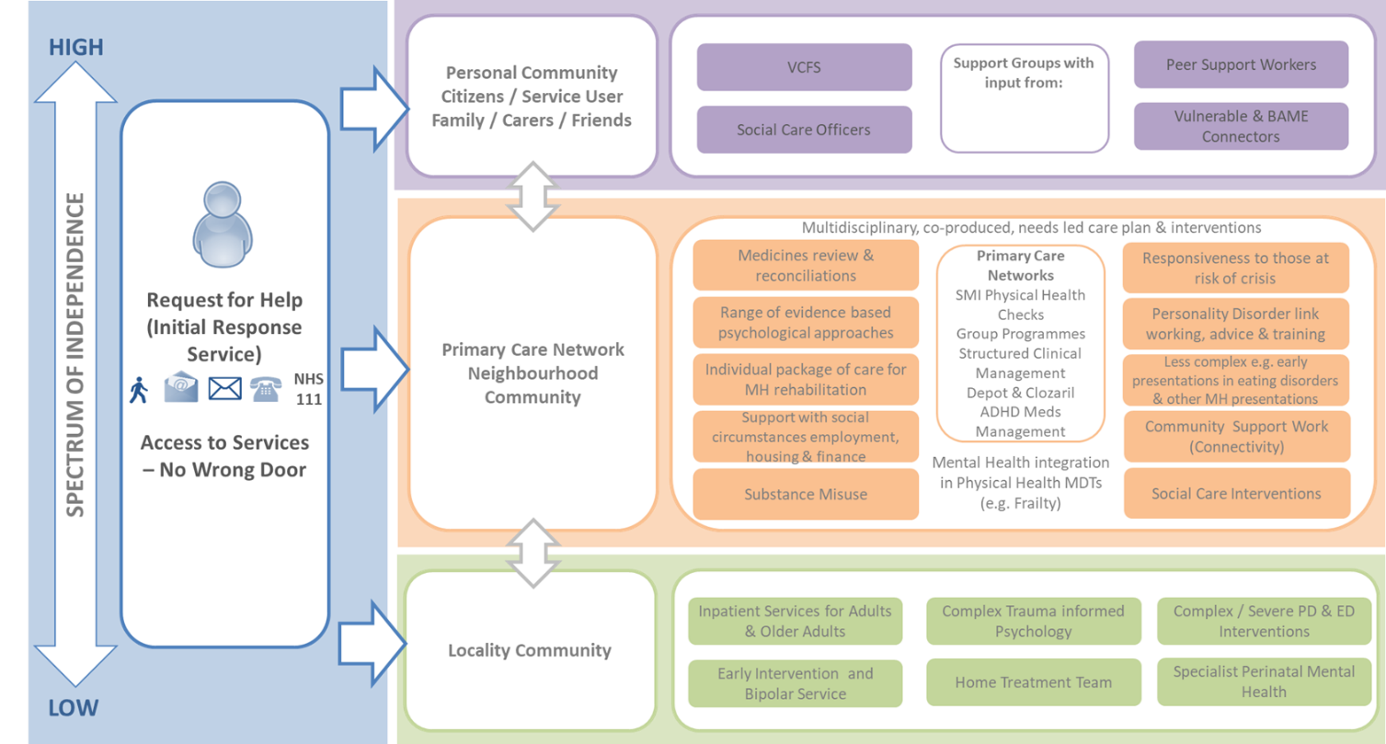

The access into the community model will be at a neighbourhood level within Primary Care Networks (PCNs); which are groups of GP practices that specifically focus on the needs of local populations. The plan is to create Community Hubs with aligned services and teams wrapped around a number of PCNs with close connections to a local network of community groups and VSCFE organisations.

The intention is that people will be able to access a multidisciplinary team (MDT) comprising:

* Mental health practitioners/consultants/support workers
* Social care staff
* VSCFE staff
* Primary care staff
* Substance misuse providers
* Housing/finance/employment support
* Peer workers

The programme will introduce a new trusted assessment and formulation model that is strengths based, and goal/solutions focussed. Assessment and formulation (with input from the full MDT) will be delivered by both statutory staff, voluntary sector staff and peer workers trained to the same standard. Where appropriate, the same staff will coproduce a personalised care and support plan and provide a range of short-term clinical, social and community interventions designed to promote recovery and reduce risk of crisis. The below chart describes a visual illustration of the ambition.

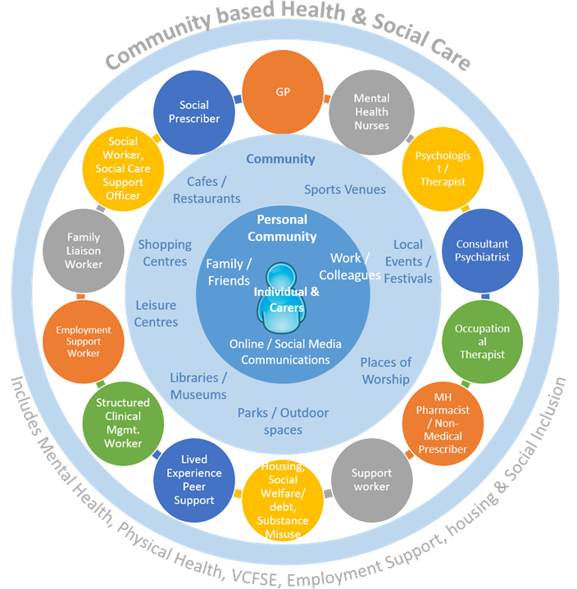

**4.0 Urgent Care Pathway – Initial Response Service**

We are implementing a new Initial Response Service (IRS) in each locality to support people in crisis as part of the community model. The aim of the service is to provide a responsive single point of access for urgent and routine requests for help, including signposting to relevant services. The intention is that by April 2022 each Locality / ICP will have the IRS service in place.

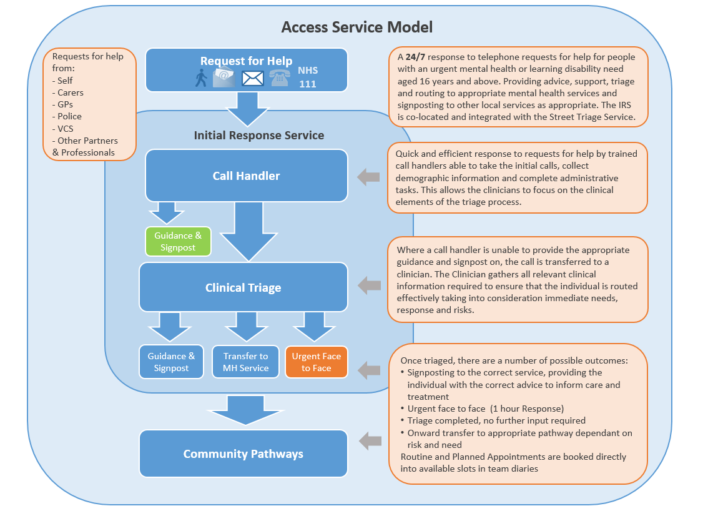

**5.0 Leadership and Governance**

The programme has established a governance structure to support the mobilisation of the programme. The key element is that the programme has introduced Partnership Groups at ICP / locality level to ensure collaboration with NHS, Local Authority, Primary Care and VCFSE partners. The Partnership groups will work in collaboration to design the community model required for the population it serves.



**6.0 Engagement**

The following activities have been planned across September to support wider participation of partners and stakeholders:

* Obtaining insights from representative groups of people with lived experience in different local communities. Ensuring we have diverse and representative and make it as easy as possible for everyone to participate (accessibility, including language and format).
* Obtaining insights from staff and peer support workers about what works well and not so well, and what’s missing.
* Undertaking mapping of local assets with partners
* Planned workshops with partners in each locality to share insights, and develop the local model based on the Community Mental Health Framework.

**7.0 Next Steps and Timelines**

Our High Level Road Map is outlined below

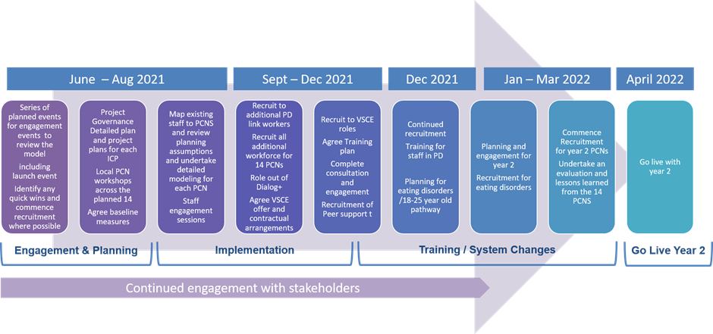

The programme has a project plan and our next steps include:

* Agreement with all stakeholders and partners the community hubs for the three year transformation programme
* Locality planning events in each ICP area with all partners, stakeholders and service users. The engagement of Lancashire County Council to date has been exemplar.
* Recruitment to all posts across the partnership groups
* Asset mapping across all PCNs that are due to go live

**9.0 The Health Scrutiny Committee is asked to**

* Note progress and next steps
* Provide support to help deliver the ambitions of the programme – the engagement from colleagues at Lancashire County Council to date has been exemplar